**PRACTICAL-7(A)**

**AIM:**

Four different departments (N0, N1, N2, and N3) of an Industry are connected in star topology to create a wired network. The link which is used is a duplex link with the queue size 5. The other parameters of link are listed below.

|  |  |  |  |
| --- | --- | --- | --- |
| Link | Bandwidth | Delay | Queue Type |
| no-n2 | 10Mbps | 10ms | DropTail |
| n1-n2 | 10Mbps | 10ms | DropTail |
| n2-n3 | 5Mbps | 10ms | DropTail |

Design simple tcl script in NS-2 for transferring FTP traffic having following characteristics.

* Packet Size: 1000
* Rate: 1
* Interval: 150

**THEORY:**

**NS2:**

* NS2 stands for Network Simulator Version 2.
* It is an open-source event-driven simulator designed specifically for research in computer communication networks.
* It is a discrete event simulator for networking research.
* It provides substantial support to simulate bunch of protocols like TCP, FTP, UDP, https and DSR.
* It simulates wired and wireless network.
* It is primarily Unix based.
* It uses TCL as its scripting language.
* NS2 consists of two key languages:
  + - C++
    - Object-oriented Tool Command Language (OTcl)
* While the C++ defines the internal mechanism (i.e., a backend) of the simulation objects, the OTcl sets up simulation by assembling and configuring the objects as well as scheduling discrete events. The C++ and the OTcl are linked together using TclCL

**Nodes**

* **Nodes can be referenced as a virtual representation of any device present in actual topology.**

**USES:**

* **NS2 is a serious rendition of Network Simulator(NS).**

* **It is generally famous for its administrations to gather and picture virtual organizations for recreation.**

* **It is better than cisco bundle tracer as every gadget in the association goes about as a hub in NS2 while a particular component qualities should be characterized in cisco(i.e if a hub is switch, switch ,and so forth.).**

* **There are numerous other comparable highlights which make NS2 more mainstream to utilize.**

**TOPOLOGY:**

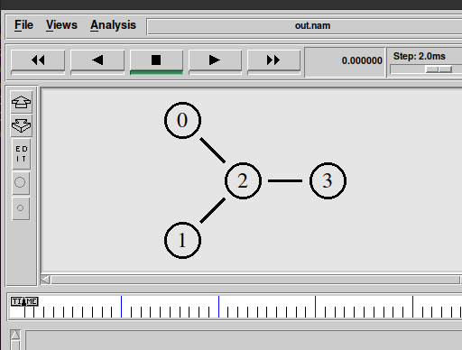

**PROGRAM CODE :**

**set ns [new Simulator]**

**$ns color 1 Blue**

**$ns color 2 Red**

**set nf [open out.nam w]**

**$ns namtrace-all $nf**

**proc finish {} {**

**global ns nf**

**$ns flush-trace**

**close $nf**

**exec nam out.nam &**

**exit 0**

**}**

**set n0 [$ns node]**

**set n1 [$ns node]**

**set n2 [$ns node]**

**set n3 [$ns node]**

**$ns duplex-link $n0 $n2 10Mb 10ms DropTail**

**$ns duplex-link $n1 $n2 10Mb 10ms DropTail**

**$ns duplex-link $n2 $n3 5Mb 10ms DropTail**

**$ns queue-limit $n2 $n3 5**

**$ns duplex-link-op $n0 $n2 orient right-down**

**$ns duplex-link-op $n1 $n2 orient right-up**

**$ns duplex-link-op $n2 $n3 orient right**

**$ns duplex-link-op $n2 $n3 queuePos 0.5**

**set tcp [new Agent/TCP]**

**$tcp set class_ 2**

**$ns attach-agent $n0 $tcp**

**set sink [new Agent/TCPSink]**

**$ns attach-agent $n3 $sink**

**$ns connect $tcp $sink**

**$tcp set fid_ 1**

**set ftp [new Application/FTP]**

**$ftp attach-agent $tcp**

**$ftp set type_ FTP**

**$ftp set packet_size_ 1000**

**$ftp set rate_ 1mb**

**set tcp [new Agent/TCP]**

**$tcp set class_ 1**

**$ns attach-agent $n1 $tcp**

**set sink [new Agent/TCPSink]**

**$ns attach-agent $n3 $sink**

**$ns connect $tcp $sink**

**$tcp set fid_ 2**

**set ftp [new Application/FTP]**

**$ftp attach-agent $tcp**

**$ftp set type_ FTP**

**$ftp set packet_size_ 1000**

**$ftp set rate_ 1mb**

**$ns at 0.5 "$ftp start"**

**$ns at 4.0 "$ftp stop"**

**$ns at 5.0 "finish"**

**$ns run**

**OUTPUT :**

* **Network Topology**



* **Data transfer in progress between nodes 1 & 3:**

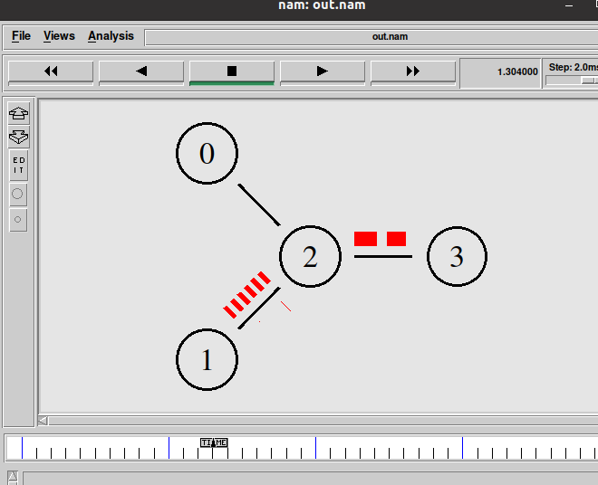

* **Packet Drop due to excess packet in queue (i.e more packets than queue capacity) :-**

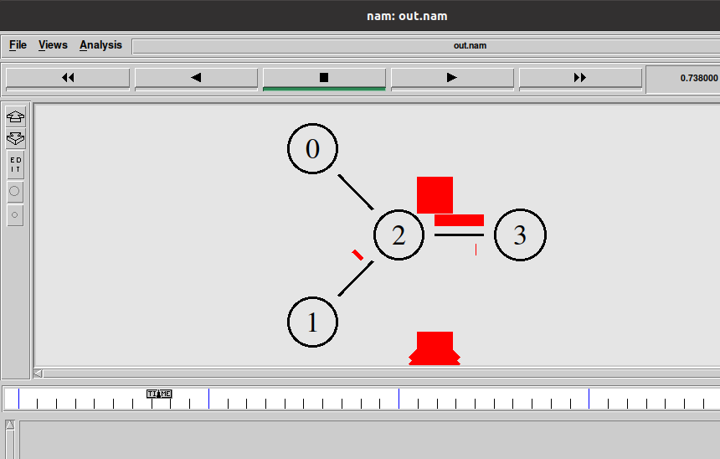

**PRACTICAL-7(B)**

**AIM:**

demonstrate various queuing mechanisms and make comparative analysis of various queuing techniques. (using trace file) (DropTail, RED, SFQ and FQ)

**THEORY:**

**SFQ:**

* **This lining system depends on reasonable lining calculation and proposed by John Nagle in 1987.**
* **Since it is illogical to have one line for every discussion SFQ utilizes a hashing calculation which isolates the traffic over a set number of lines.**
* **It isn't so effective than different lines instruments however it additionally requires less computation while being completely reasonable.**
* **It is classified "Stochastic" because of the explanation that it doesn't really relegate a line for each meeting; it has a calculation which partitions traffic over a confined number of lines utilizing a hashing calculation.**
* **SFQ allocates an entirely enormous number of FIFO lines.**

**FQ (Fair Queuing):**

* **It is a lining component that is utilized to permit numerous parcels stream to similarly share the connection limit.**
* **Switches have different lines for each yield line for each client.**
* **At the point when a line as accessible as inactive switches filters the lines through cooperative effort and takes first parcel to next line.**
* **FQ likewise guarantee about the most extreme throughput of the organization.**
* **For more effectiveness weighted line system is additionally utilized.**

**RED:**

* Random Early Detection (RED) is a congestion avoidance queuing mechanism (as opposed to a congestion administration mechanism) that is potentially useful, particularly in high-speed transit networks.
* Sally Floyd and Van Jacobson projected it in various papers in the early 1990s.
* It is active queue management mechanism.
* It operates on the average queue size and drop packets on the basis of statistics information.
* If the buffer is empty all incoming packets are acknowledged.
* As the queue size increase the probability for discarding a packet also increase.
* When buffer is full probability becomes equal to 1 and all incoming packets are dropped.

**PROGRAM CODE:**

**SFQ:**

set ns [new Simulator]

$ns color 1 Blue

$ns color 2 Red

set nf [open prac2.nam w]

$ns namtrace-all $nf

set nr [open prac2.tr w]

$ns trace-all $nr

#Define a 'finish' procedure

proc finish {} {

global ns nf nr

$ns flush-trace

#Close the NAM trace file

close $nf

close $nr

#Execute NAM on the trace file

exec nam prac2.nam &

exit 0

}

set n0 [$ns node]

set n1 [$ns node]

set n2 [$ns node]

set n3 [$ns node]

set n4 [$ns node]

set n5 [$ns node]

$n0 shape circle

$n1 shape circle

$n2 shape circle

$n3 shape circle

$n4 shape circle

$n5 shape circle

$n0 label "1 Node"

$n1 label "2 Node"

$n2 label "3 Node"

$n3 label "4 Node"

$n4 label "5 Node"

$n5 label "6 Node"

$ns duplex-link $n0 $n2 10Mb 10ms SFQ

$ns duplex-link $n1 $n2 10Mb 10ms SFQ

$ns duplex-link $n2 $n3 5Mb 5ms SFQ

$ns duplex-link $n3 $n4 10Mb 10ms SFQ

$ns duplex-link $n3 $n5 10Mb 10ms SFQ

$ns queue-limit $n0 $n2 10

$ns queue-limit $n1 $n2 10

$ns queue-limit $n2 $n3 5

$ns queue-limit $n3 $n4 10

$ns queue-limit $n3 $n5 10

$ns duplex-link-op $n0 $n2 orient down-right

$ns duplex-link-op $n1 $n2 orient up-right

$ns duplex-link-op $n2 $n3 orient right

$ns duplex-link-op $n3 $n4 orient up-right

$ns duplex-link-op $n3 $n5 orient down-right

set tcp [new Agent/TCP]

$tcp set class_ 2

$ns attach-agent $n0 $tcp

set sink [new Agent/TCPSink]

$ns attach-agent $n4 $sink

$ns connect $tcp $sink

$tcp set fid_ 1

set ftp [new Application/FTP]

$ftp attach-agent $tcp

$ftp set type_ FTP

$ftp set packet_size_ 1000

$ftp set rate_ 1mb

$ftp set interval_ 150

set udp [new Agent/UDP]

$udp set class_ 2

$ns attach-agent $n1 $udp

set sink1 [new Agent/Null]

$ns attach-agent $n5 $sink1

$ns connect $udp $sink1

$udp set fid_ 2

set cbr [new Application/Traffic/CBR]

$cbr attach-agent $udp

$cbr set type_ CBR

$cbr set packet_size_ 1500

$cbr set rate_ 0.05mb

$cbr set interval_ 150

$ns at 1.0 "$ftp start"

$ns at 4.0 "$ftp stop"

$ns at 2.0 "$cbr start"

$ns at 4.5 "$cbr stop"

$nsat5.0"finish"  
$ns r

**OUTPUT:**

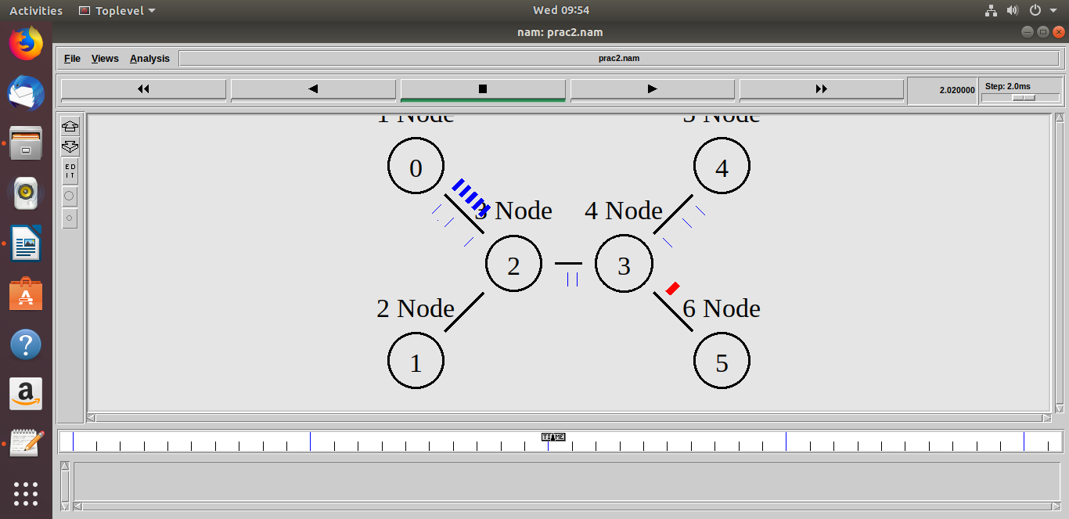

**FQ:**

set ns [new Simulator]

$ns color 1 Blue

$ns color 2 Red

set nf [open prac3.nam w]

$ns namtrace-all $nf

set nr [open prac3.tr w]

$ns trace-all $nr

#Define a 'finish' procedure

proc finish {} {

global ns nf nr

$ns flush-trace

#Close the NAM trace file

close $nf

close $nr

#Execute NAM on the trace file

exec nam prac3.nam &

exec awk -f through.awk prac3.tr &

exit 0 }

set n0 [$ns node]

set n1 [$ns node]

set n2 [$ns node]

set n3 [$ns node]

set n4 [$ns node]

set n5 [$ns node]

$n0 shape circle

$n1 shape circle

$n2 shape circle

$n3 shape circle

$n4 shape circle

$n5 shape circle

$n0 label "1 Node"

$n1 label "2 Node"

$n2 label "3 Node"

$n3 label "4 Node"

$n4 label "5 Node"

$n5 label "6 Node"

$ns duplex-link $n0 $n2 10Mb 10ms FQ

$ns duplex-link $n1 $n2 10Mb 10ms FQ

$ns duplex-link $n2 $n3 5Mb 5ms FQ

$ns duplex-link $n3 $n4 10Mb 10ms FQ

$ns duplex-link $n3 $n5 10Mb 10ms FQ

$ns queue-limit $n0 $n2 10

$ns queue-limit $n1 $n2 10

$ns queue-limit $n2 $n3 5

$ns queue-limit $n3 $n4 10

$ns queue-limit $n3 $n5 10

$ns duplex-link-op $n0 $n2 orient down-right

$ns duplex-link-op $n1 $n2 orient up-right

$ns duplex-link-op $n2 $n3 orient right

$ns duplex-link-op $n3 $n4 orient up-right

$ns duplex-link-op $n3 $n5 orient down-right

set tcp [new Agent/TCP]

$tcp set class_ 2

$ns attach-agent $n0 $tcp

set sink [new Agent/TCPSink]

$ns attach-agent $n4 $sink

$ns connect $tcp $sink

$tcp set fid_ 1

set ftp [new Application/FTP]

$ftp attach-agent $tcp

$ftp set type_ FTP

$ftp set packet_size_ 1000

$ftp set rate_ 1mb

$ftp set interval_ 150

set udp [new Agent/UDP]

$udp set class_ 2

$ns attach-agent $n1 $udp

set sink1 [new Agent/Null]

$ns attach-agent $n5 $sink1

$ns connect $udp $sink1

$udp set fid_ 2

set cbr [new Application/Traffic/CBR]

$cbr attach-agent $udp

$cbr set type_ CBR

$cbr set packet_size_ 1500

$cbr set rate_ 0.05mb

$cbr set interval_ 150

$ns at 1.0 "$ftp start"

$ns at 4.0 "$ftp stop"

$ns at 2.0 "$cbr start"

$ns at 4.5 "$cbr stop"

$ns at 5.0 "finish"

$ns run

**OUTPUT:**

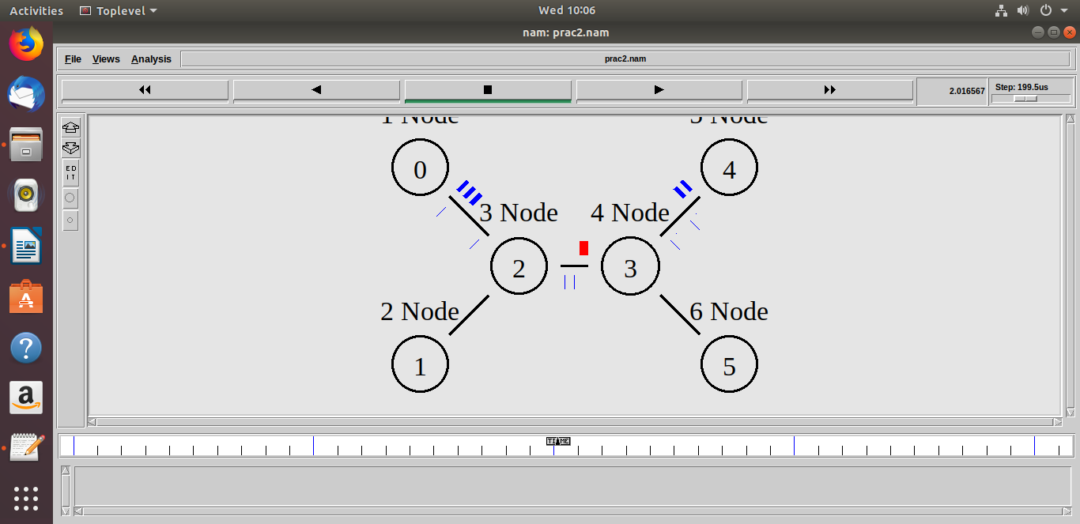

**Droptail:**

set ns [new Simulator]

$ns color 1 Blue

$ns color 2 Red

set nf [open prac3.nam w]

$ns namtrace-all $nf

set nr [open prac3.tr w]

$ns trace-all $nr

#Define a 'finish' procedure

proc finish {} {

global ns nf nr

$ns flush-trace

#Close the NAM trace file

close $nf

close $nr

#Execute NAM on the trace file

exec nam prac3.nam &

exec awk -f through.awk prac3.tr &

exit 0 }

set n0 [$ns node]

set n1 [$ns node]

set n2 [$ns node]

set n3 [$ns node]

set n4 [$ns node]

set n5 [$ns node]

$n0 shape circle

$n1 shape circle

$n2 shape circle

$n3 shape circle

$n4 shape circle

$n5 shape circle

$n0 label "1 Node"

$n1 label "2 Node"

$n2 label "3 Node"

$n3 label "4 Node"

$n4 label "5 Node"

$n5 label "6 Node"

$ns duplex-link $n0 $n2 10Mb 10ms DropTail

$ns duplex-link $n1 $n2 10Mb 10ms DropTail

$ns duplex-link $n2 $n3 5Mb 5ms DropTail

$ns duplex-link $n3 $n4 10Mb 10ms DropTail

$ns duplex-link $n3 $n5 10Mb 10ms DropTail

$ns queue-limit $n0 $n2 10

$ns queue-limit $n1 $n2 10

$ns queue-limit $n2 $n3 5

$ns queue-limit $n3 $n4 10

$ns queue-limit $n3 $n5 10

$ns duplex-link-op $n0 $n2 orient down-right

$ns duplex-link-op $n1 $n2 orient up-right

$ns duplex-link-op $n2 $n3 orient right

$ns duplex-link-op $n3 $n4 orient up-right

$ns duplex-link-op $n3 $n5 orient down-right

set tcp [new Agent/TCP]

$tcp set class_ 2

$ns attach-agent $n0 $tcp

set sink [new Agent/TCPSink]

$ns attach-agent $n4 $sink

$ns connect $tcp $sink

$tcp set fid_ 1

set ftp [new Application/FTP]

$ftp attach-agent $tcp

$ftp set type_ FTP

$ftp set packet_size_ 1000

$ftp set rate_ 1mb

$ftp set interval_ 150

set udp [new Agent/UDP]

$udp set class_ 2

$ns attach-agent $n1 $udp

set sink1 [new Agent/Null]

$ns attach-agent $n5 $sink1

$ns connect $udp $sink1

$udp set fid_ 2

set cbr [new Application/Traffic/CBR]

$cbr attach-agent $udp

$cbr set type_ CBR

$cbr set packet_size_ 1500

$cbr set rate_ 0.05mb

$cbr set interval_ 150

$ns at 1.0 "$ftp start"

$ns at 4.0 "$ftp stop"

$ns at 2.0 "$cbr start"

$ns at 4.5 "$cbr stop"

$ns at 5.0 "finish"

**OUTPUT:**

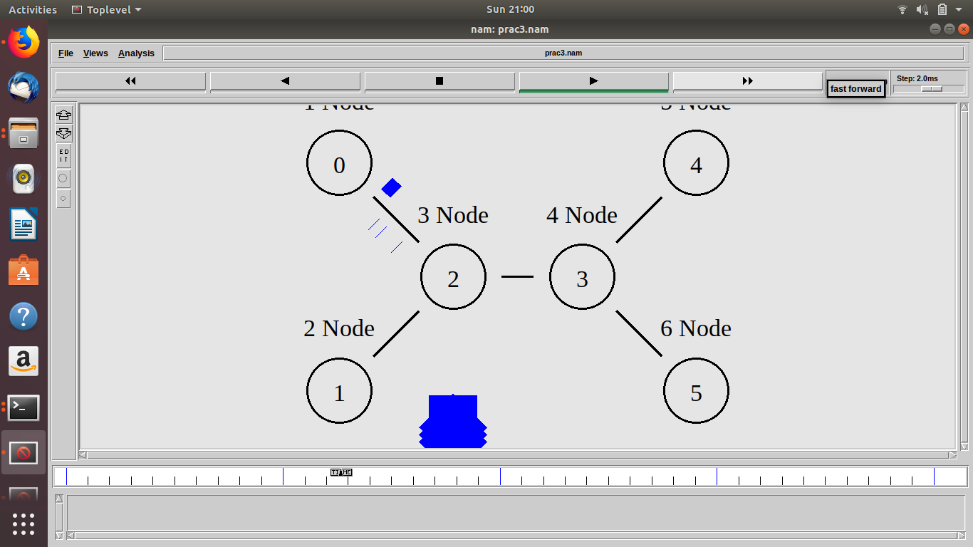

**RED:**

set ns [new Simulator]

$ns color 1 Blue

$ns color 2 Red

set nf [open prac3.nam w]

$ns namtrace-all $nf

set nr [open prac3.tr w]

$ns trace-all $nr

#Define a 'finish' procedure

proc finish {} {

global ns nf nr

$ns flush-trace

#Close the NAM trace file

close $nf

close $nr

#Execute NAM on the trace file

exec nam prac3.nam &

exec awk -f through.awk prac3.tr &

exit 0 }

set n0 [$ns node]

set n1 [$ns node]

set n2 [$ns node]

set n3 [$ns node]

set n4 [$ns node]

set n5 [$ns node]

$n0 shape circle

$n1 shape circle

$n2 shape circle

$n3 shape circle

$n4 shape circle

$n5 shape circle

$n0 label "1 Node"

$n1 label "2 Node"

$n2 label "3 Node"

$n3 label "4 Node"

$n4 label "5 Node"

$n5 label "6 Node"

$ns duplex-link $n0 $n2 10Mb 10ms RED

$ns duplex-link $n1 $n2 10Mb 10ms RED

$ns duplex-link $n2 $n3 5Mb 5ms RED

$ns duplex-link $n3 $n4 10Mb 10ms RED

$ns duplex-link $n3 $n5 10Mb 10ms RED

$ns queue-limit $n0 $n2 10

$ns queue-limit $n1 $n2 10

$ns queue-limit $n2 $n3 5

$ns queue-limit $n3 $n4 10

$ns queue-limit $n3 $n5 10

$ns duplex-link-op $n0 $n2 orient down-right

$ns duplex-link-op $n1 $n2 orient up-right

$ns duplex-link-op $n2 $n3 orient right

$ns duplex-link-op $n3 $n4 orient up-right

$ns duplex-link-op $n3 $n5 orient down-right

set tcp [new Agent/TCP]

$tcp set class_ 2

$ns attach-agent $n0 $tcp

set sink [new Agent/TCPSink]

$ns attach-agent $n4 $sink

$ns connect $tcp $sink

$tcp set fid_ 1

set ftp [new Application/FTP]

$ftp attach-agent $tcp

$ftp set type_ FTP

$ftp set packet_size_ 1000

$ftp set rate_ 1mb

$ftp set interval_ 150

set udp [new Agent/UDP]

$udp set class_ 2

$ns attach-agent $n1 $udp

set sink1 [new Agent/Null]

$ns attach-agent $n5 $sink1

$ns connect $udp $sink1

$udp set fid_ 2

set cbr [new Application/Traffic/CBR]

$cbr attach-agent $udp

$cbr set type_ CBR

$cbr set packet_size_ 1500

$cbr set rate_ 0.05mb

$cbr set interval_ 150

$ns at 1.0 "$ftp start"

$ns at 4.0 "$ftp stop"

$ns at 2.0 "$cbr start"

$ns at 4.5 "$cbr stop"

$ns at 5.0 "finish"

$ns run

**OUTPUT:**

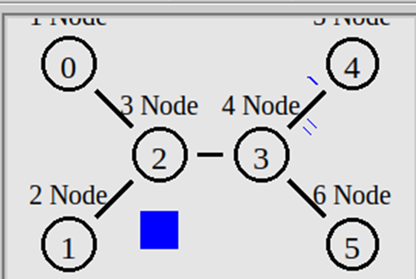

**CONCLUSION:**

* By performing the above practicals, we learned the the basic concepts of NS2.
* We also learnt about how to create a topology in NS2.
* We also learnt about how to transfer data.
* We also learnt various queing techniques.